Project Executable Files
Date | 6 July, 2026
Team ID
Project Name | UCab - Online Cab Booking System
Maximum Marks | 3 Marks

Project Executable Files


Step 1: Submission Checklist
S.No | Item to Submit | Submitted (Yes /  No / NA)
1 | Complete source code (all files and folders) | Yes
2 | README / Setup Guide (instructions to run the project) | Yes
3 | package.json | Yes
4 | Database schema | Yes
5 | .env.example | Yes
6 | Deployed application URL (if hosted) | NA
7 | APK / Executable binary (if applicable for mobile/desktop apps) | NA
9 | Test files and test results | Yes
10 | Demo video or walkthrough (if required) | YES



Step 2: File / Folder Structure
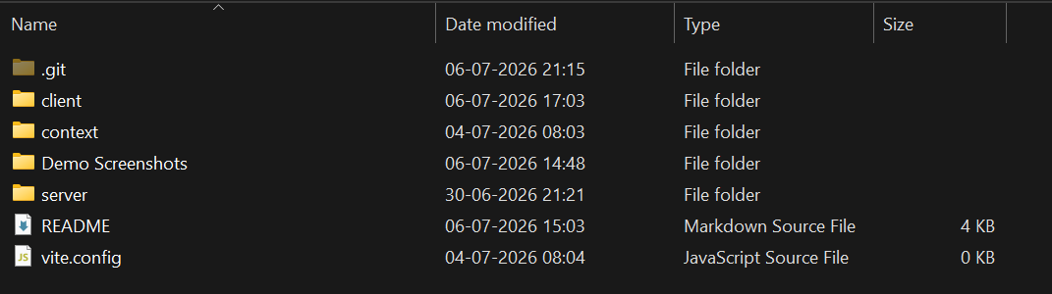
Step 3: Deployment / Access Details

Field | Details
Repository Link | https://github.com/MaheswarReddy39/ucab
Demo Video Link | https://drive.google.com/file/d/1pusB12rcv4Ynhwwgw35U5SoG9jIwje5d/view?usp=sharing
Login Credential s (Demo) | No Need For Credentials

